Here is how a simple JSON piece of data may look (140 characters):

{

"id": 123,

"title": "Object Thinking",

"author": "David West",

"published": {

"by": "Microsoft Press",

"year": 2004

}

}

A similar document would look like this in XML (167 characters):

<?xml version="1.0"?>

<book id="123">

<title>Object Thinking</title>

<author>David West</author>

<published>

<by>Microsoft Press</by>

<year>2004</year>

</published>

</book>

JSON is a good data format, and it is just a data format

Looks easy to compare, right? The first example is a bit shorter, is easier to understand since it's less "cryptic," and is also perfectly parseable in JavaScript. That's it, then; let's use JSON and manifest the death of XML! Who needs this heavyweight 15-year-old XML in the first place?

Well, I need it, and I love it. Let me explain why.

And don't get me wrong; I'm not against JSON. Not at all. It's a good **data format**. But it's just a data format. We're using it **temporarily** to transfer a piece of data from point A to point B. Indeed, it is shorter than XML and more readable. That's it.

[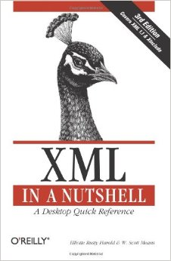](http://www.amazon.com/gp/product/0596007647/ref=as_li_tl?ie=UTF8&camp=1789&creative=390957&creativeASIN=0596007647&linkCode=as2&tag=yegor256com-20&linkId=MWLP356M3CQZSBS7)

XML is not a data format; it is a **language**. A very powerful one. Let me show you what it's capable of. Let me basically explain why I love it. And I would strongly recommend you read [**XML in a Nutshell, Third Edition**](http://www.amazon.com/gp/product/0596007647/ref=as_li_tl?ie=UTF8&camp=1789&creative=390957&creativeASIN=0596007647&linkCode=as2&tag=yegor256com-20&linkId=MWLP356M3CQZSBS7) by Elliotte Rusty Harold and W. Scott Means.

<http://www.yegor256.com/2015/11/16/json-vs-xml.html>